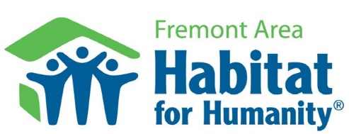
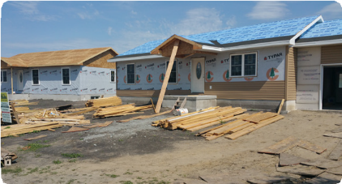
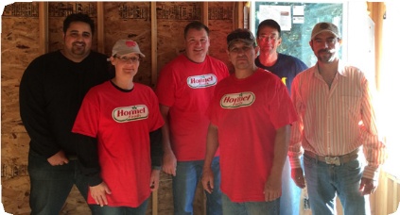
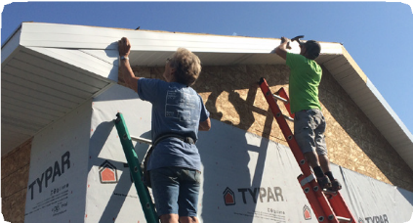
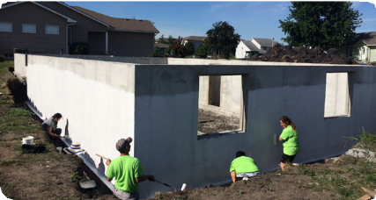
Creating A World Where Everyone Has A Decent Place To Live

TEAM BUILD DAYS

Our Team Build Days are a great opportunity for a company to engage their employees in a positive team-building activity while tangibly giving back to the community.

TEAM BUILD - Adopt-a-Day Sponsors
Donation level: Varies

This opportunity is for one, full construction day experience, with number of volunteer slots and benefits for your
organization varying with sponsorship levels. Days available: Thursday, Friday and Saturday.

How does it work?
- NO EXPERIENCE NECESSARY
- We host your group at one of our active build sites and provide all materials needed
- Teams are led by our construction manager

Benefits to Your Organization | Gold  $2,500 donation  (Up to 25 volunteers) | Silver  $1,000 donation  (Up to 10 volunteers) | Bronze  No cost  (Up to 10 volunteers)
Use of Habitat’s logo on your website | x
Personalized Habitat shirts for group | x
Recognition in our bi-annual newsletter | x
Recognition in Annual Report | x
Website promotion-includes link to business webpage on our website | x | x
Facebook/social media post with group photo | x | x | x
Assistance with organizing your group and planning Team Build Day | x | x | x
The knowledge that your time and sponsorship makes a difference in the Fremont community and transforms the lives of local families | x | x | x

For more information or to set up a Team Build event, please contact
Marin Laferla at 721-8771 or marin@fremonthabitat.org.

701 East Dodge Street, Fremont, NE 68025 • (402) 721-8771 • fremonthabitat.org

